## horizontal line

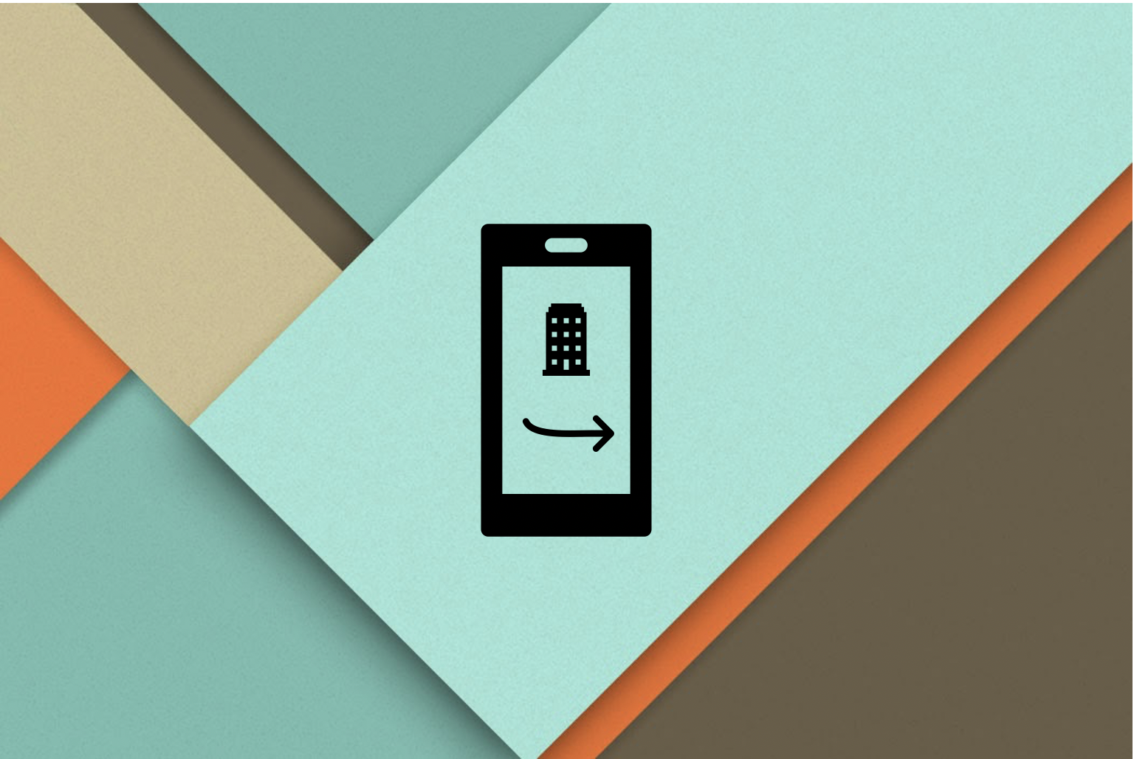

Indoor Cross-floor Navigation

Paper Proposal

03.05.2020

**─**

Zixiao Wang

Northeastern University

# 

# Content

**Content** **1**

**Overview** **2**

**Goals** **3**

**Specifications** **3**

Environment assumption 3

The program design 3

Implementation and Evaluation 4

**Milestones for 5.3 - 5.10** **5**

Cross-floor navigation program implementation 5

First paper draft 5

# 

# Overview

The indoor navigation system refers to the use of different technologies in various indoor spaces to achieve indoor navigation of personnel and the positioning and tracking of people and objects. Such a system mainly includes four parts: Positioning, pathfinding, navigation, visualization.

In these four areas, positioning and pathfinding are the most important factors.

Generally speaking, there are two main categories for positioning. That is sensor-based positioning technology (infrared positioning, ultrasonic positioning) and radiofrequency (RF) signal-based positioning technology (Wifi positioning, Bluetooth and ZigBee positioning).

Here, RF positioning technology usually has a higher performance during practice environments. However, existing indoor navigation suppliers, like insoft [1], concept3d [2], often use fusion positioning technology, that is, combining multiple positioning technologies to achieve a higher accuracy positioning effect.

As for pathfinding, there are also a lot of algorithms that can help us. Like breadth first search,Dijkstra’s Algorithm and A* algorithm. A* algorithm is the most commonly used pathfinding method during practice environments.

Navigation always combines with the visualization. By updating the user's real-time position and the current found path, the system can provide a navigation service. The system will allow the user to choose a floor from a particular building. After the user chooses the destination, the system will navigate the user to the place he wants. The commonly used visualization method is 2D overlooking the map.

However, current indoor navigation systems often only consider single-layer navigation and do not support cross-floor navigation very well. For example, the user is now on the first floor, but he wants to go to a location on the third floor. At this time, when the system is navigating, it can only use the positioning information from the overlooking view, assuming that the user has reached the third floor, and then navigate the user to the specified location. I call this indoor navigation mode as “2D navigation mode”.

In order to solve this problem. The paper will introduce a new method that allows the system to help the user do cross-floor navigation. That is, when the user chooses a destination that is not on the same floor with the user, the system will consider navigating the user to the “place that can change the floor” (i.e elevator, stair, etc) first. And I will call this kind of navigation mode “3D navigation mode”.

# **Goals**

The main goal of the paper is to explain the theory about “3D navigation mode”. At the same time, make the result reproducible.

The paper will include:

1. The environment assumption during the paper
2. The program design for “3D navigation mode”
3. The implementation and performance evaluation
4. Program original code github link
5. Future outlook

# Specifications

During this paper, there is something that needs to be drawn in a particular range.

## Environment assumption

A complete indoor navigation will include building map data, user positioning, navigation, visualization.

This is because the paper is mainly focused on the “3D navigation mode”, so other parts should be assumed properly.

For getting building map data. I don't have access to contact building contractors, county clerks, owners or developers. As such I simulate building blueprints for the different floors of the building using architecture software.

For the case of continuously detecting current user location I will use the Bluetooth low energy technology beacons strategically placed in the building and assume the user’s device can connect to these beacons. Since financial limitation, I will be using virtually initialised and setup beacons and use it to simulate path generation using the algorithms.

For the visualization and user interface, I will only focus on a simple mapping visualization. However, if there is some time left, I will try to implement the visualization in a VR style.

## The program design

This will mainly include two parts.

The first part will be the logic design, which includes positioning, pathfinding, and navigation. And explain the 3D navigation scene by using use case and sequence diagram.

The second part will include the MySQL database design. The paper will explain the theory by combining the logic design with the database ERD diagram.

## Implementation and Evaluation

In this portation, the paper will give a brief explanation about the program implementation. In order to make it reproducible. The paper will attach the github link for the original code. (I will use the MIT open source license).

Then the paper will evaluation the program design in the following field: effectiveness, time cost, and space cost

# 

# **Milestones** for **5.3 - 5.10**

## Cross-floor navigation program implementation

This is because during the final project, I didn’t actually achieve the multi-floor navigation. I only implement the single-floor navigation. So I need some time to implement this part. And during this part, I will recheck the program logic diagram again.

Time cost estimation:

1. Code reconstruction: 3 Hours
2. Cross-floor implementation: 6 Hours

## First paper draft

Paper title: Program Design and Implementation for Cross-floor Indoor Navigation

I’m thinking to write the paper in such order:

1. Abstract
2. Introduction
3. Environment Assumption
4. Program Design
5. Implementation and Evaluation
6. Future Outlook
7. Reference

Time cost estimation: 6 - 10 Hours

I’m planning to drive about 4 - 6 hours for this paper everyday. Based on time estimation, I will finish the first paper draft in 5.8. No later than 5.10

**Reference**

[1] Solutions for Real-Time Locating Systems (RTLS) by infsoft. (2020). Retrieved 1 May 2020, from <https://www.infsoft.com/>

[2] 3D Mapping and Virtual Tour Software | Concept3D. (2020). Retrieved 2 May 2020, from <https://www.concept3d.com/>

[3] Xia, S., Liu, Y., Yuan, G., Zhu, M., & Wang, Z. (2017). Indoor fingerprint positioning based on Wi-Fi: An overview. ISPRS International Journal of Geo-Information, 6(5), 135.

[4] 高伟, 侯聪毅, 许万旸, & 陈玄. (2019). 室内导航定位技术研究进展与展望. 导航定位学报, (1), 2.